Pediatric Clinical Mentoring – HIV-infected children now have access to care

International Center for Equal Healthcare Access
Vietnam Program Update – June 2006
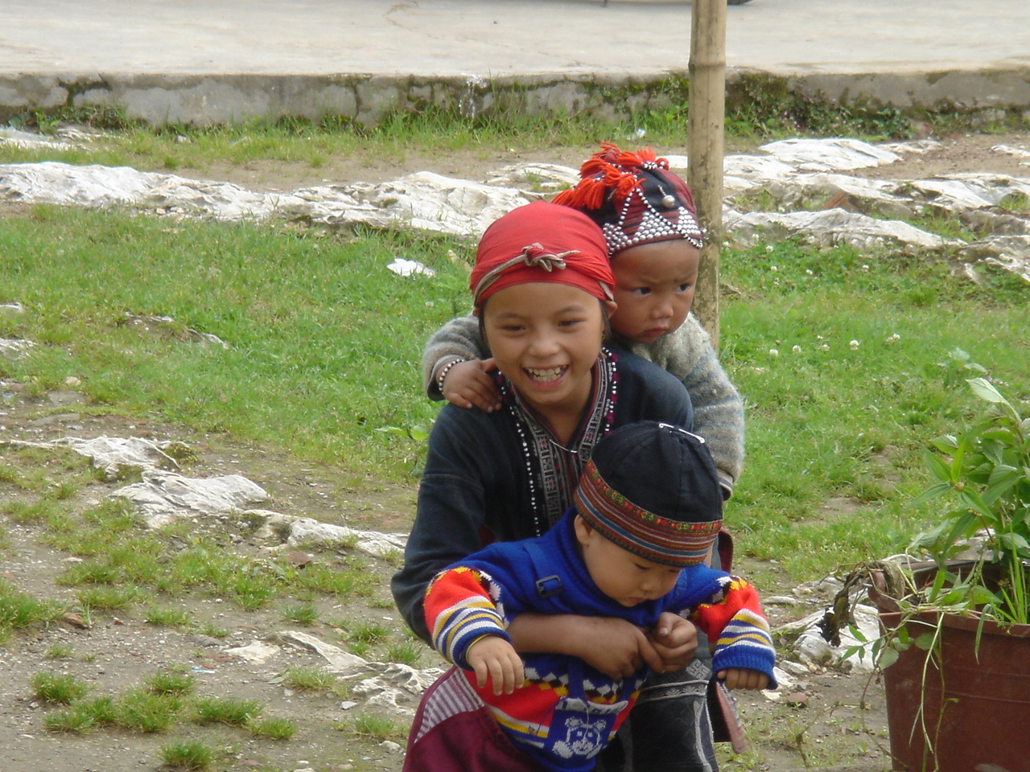
Treating kids with HIV is very different from taking care of adults with HIV. While all clinical mentoring has addressed the provision of care for children, the program is making a specific commitment to specifically develop local pediatric expertise in the care and prevention of HIV and AIDS.

ICEHA clinical mentors have recently spent time in the pediatric hospitals in Ho Chi Minh City. Their goal is to “mentor pediatric infectious disease physicians who provide care to the majority of children in the city as well as the referral districts.” While the doctors have received didactic training, ICEHA mentors learned that they had very little practical or operational experience. The coaching provided by ICEHA clinical mentors provides rapid strengthening of clinical expertise which in turn means that children with HIV receive the most expert care within the available resources.
Achievements
- Initiation of pediatric focused clinical mentoring
- 19 clinical mentors have deployed
- Approximately 850 days of clinical mentoring have been provided
- 9 different settings have received ICEHA clinical mentors
- Two clinics “mentored out”

The pediatric HIV outpatient clinics at Pediatric Hospitals1 and 2 in Ho Chi Minh City are “up and humming”. Ongoing support from ICEHA clinical mentors will address new issues and will reinforce best practices.

ICEHA’s goal is for the local health professionals to develop clinical expertise in pediatric HIV/AIDS treatment and prevention.

For more information visit: www.iceha.org

